Kyle Krug
Northwestern University
MSDS 451
Checkpoint Assignment A

Developing a Quantitative Plan for Managing the Anabasis Transformative Technology Fund (ATTF)
Introduction
This paper presents my thesis for the Anabasis Transformative Technology Fund (ATTF) and defines a research plan to validate or revise how such a fund should be managed. I have conceived the fund as an actively managed exchange-traded fund (ETF) that targets transformational technologies such as artificial intelligence (AI) infrastructure, robotics and space, public blockchains and cryptocurrency ETFs, and frontier areas such as quantum computing and electric Vertical Take-Off and Landing (eVTOL) aviation. These domains combine steep learning curves, rapid adoption dynamics, and heightened sensitivity to policy, i.e., regulations and approvals, and interest-rate cycles. Those same forces create both asymmetric opportunity and crash risk. My thesis is that a technology-first fund, augmented by quantitative, rules-based management, can better capture long-term upside while constraining the left tail typical of innovation themes. The intended users of the resulting knowledge base and tooling are investors who want transparent, systematic access to transformational technology exposures, students and researchers who can reuse the codebase, and product and risk teams assessing ETF-compatible processes for thematic strategies. Industry precedent from ARK Invest, its sole focus on disruptive innovation, open research, top-down and bottom-up processes, and multi-year horizon, provides the thematic rationale, which this plan subjects to quantitative testing.
Literature Review
The academic and industry literature provides staunch support for building a systematic, rules-based strategy around transformational technologies. I conducted academic research based on the course’s bibliographies, online research, and finally, I focused research on how and why ARK Invest develops and implements their investment plans. Momentum and trend-following studies, such as Jegadeesh and Titman (1993), demonstrate that persistence in stock returns can be systematically exploited. Grinold and Kahn (2000) articulate the “fundamental law of active management,” which argues that performance depends both on forecasting skill and breadth of independent opportunities, a principle that applies directly to diversified exposure across AI, space, cryptocurrencies, and other experimental assets. Moreira and Muir (2017) further argue that “managed portfolios that take less risk when volatility is high produce large alphas, increase Sharpe ratios, and produce large utility gains for mean-variance investors,” demonstrating that volatility-managed portfolios can improve risk-adjusted returns by scaling exposure based on risk regimes. In practical, applied texts, Clenow’s Trading Evolved (2019) demonstrates how “systematic trading allows you to test and evaluate your trading ideas before risking your money” and emphasizes that “following systematic rules provides a consistent approach where you will have some degree of predictability of returns,” showing how systematic trading strategies can be developed and tested in Python. Rubano’s Trader Construction Kit (2020) provides a roadmap for building explicit rule-based trading systems. To augment these academic sources, I conducted online research on ARK’s approach. ARK offers a well-documented rationale for focusing on disruptive innovation, defining it as the introduction of technologically enabled products and services that change how the world works, and emphasizing a process that blends top-down and bottom-up work within an Open Research Ecosystem, typically over a five-year investment horizon.
Methods
This research aims to determine whether an actively managed, rules-based ETF offers superior risk-adjusted returns compared to a passive, buy-and-hold strategy in markets defined by transformational technologies. The central question is whether the additional complexity, turnover, and data-driven decision rules of active management create measurable value relative to passive allocation among technology-themed assets. The analysis will simulate both approaches. The passive portfolio will maintain static weights in key innovation sectors, and the active portfolio will apply algorithmic trading rules such as trend-following and volatility targeting. Comparing these strategies over multiple market cycles will help clarify whether active management is justified in the context of innovation-driven equities.
The guiding investment philosophy under investigation is technology-first but quantitatively enforced. The thematic foundation follows ARK Invest’s research focus, which identifies “companies that we expect to be leaders, enablers, and beneficiaries of disruptive innovation.” (ARK Invest, 2025) ARK relies primarily on discretionary, conviction-based management, however this study proposes to systematize similar thematic exposures through explicit quantitative rules and to evaluate whether doing so improves consistency and risk control.
This initial research focuses exclusively on technical analysis frameworks using price and volatility patterns as the primary signals for security selection and portfolio timing. This design choice warrants explicit justification given the nature of transformational technology investing. Traditional fundamental metrics such as price-to-earnings ratios, price-to-sales multiples, and discounted cash flow models prove problematic for frontier technology companies where many holdings are pre-revenue, such as eVTOL, quantum computing at time horizon for this study, generate negative cash flows during scale-up phases, or trade at valuation multiples that defy conventional analysis frameworks. While ARK Invest successfully incorporates innovation-specific fundamental metrics including Wright’s Law cost-decline curves, total addressable market sizing, technology adoption S-curves, and patent quality analysis, implementing such metrics requires proprietary research infrastructure, industry-specific domain expertise, and subjective judgment that does not lend itself to fully automated, rules-based execution.
The decision to rely on purely technical signals for this checkpoint reflects both practical constraints and theoretical considerations. From a practical standpoint, price-based momentum and trend-following signals can be systematically extracted from readily available market data, backtested without look-ahead bias, and implemented in real-time trading systems without requiring fundamental research teams or access to proprietary databases. From a theoretical perspective, as Grinold and Kahn observe, the most successful active managers are those who can systematically transform superior forecasts into superior portfolios, and momentum-based technical signals have demonstrated robust out-of-sample performance across asset classes and time periods. Furthermore, for transformational technologies where information asymmetry is severe and traditional valuation frameworks fail, price momentum may actually serve as a more reliable signal than fundamental metrics, as it aggregates the collective wisdom of all market participants including venture capitalists, industry experts, and early adopters who possess superior information.
However, this technical-only approach represents a significant limitation that future research must address. Future deliverables will evaluate whether incorporating innovation-specific fundamental overlays improves performance beyond pure momentum signals. Candidate fundamental metrics include research and development expenditure as a percentage of revenue, patent filing velocity and citation quality, revenue growth acceleration rates, gross margin expansion trajectories for companies transitioning from prototype to commercial production, and management team backgrounds in terms of prior successful ventures and technical credentials. The hypothesis is that combining technical signals for timing with fundamental filters for security selection may yield superior rather than fundamental progress. For example, a hybrid approach might select the top momentum securities within each sleeve but exclude those with declining R&D intensity, deteriorating gross margins, or management teams lacking relevant domain expertise, thereby reducing exposure to companies whose price momentum may reverse when fundamental weaknesses become apparent.
Candidate active strategies will employ explicit, automatable rules for buying and selling securities. Each sector the fund is seeking to invest in, i.e., AI infrastructure, will be evaluated under trend-following and volatility-targeted regimes. For baseline (S1), securities are ranked by 90-day price momentum. For dual momentum (S2), securities must show positive momentum on both 60-day and 120-day lookbacks, and rankings use the average of these two signals. The strategies rebalance monthly, selecting the top two securities per sleeve based on momentum rankings. This reactive, price-based process reflects the adaptive logic of managed-futures strategies. As Greyserman and Kaminski note, “trend following provides a simple but robust approach to trading that adapts to a changing market environment without forecasting.”
The study will implement systematic portfolio selection consistent with Modern Portfolio Theory and efficient-frontier optimization. In 1952, Markowitz demonstrated that diversifications across imperfectly correlated assets can reduce risk without sacrificing expected return, and Sharpe in 1964 formalized that investors will choose portfolios that are efficient in the sense that no other portfolio offers higher expected return for the same risk. Building on these principles, this checkpoint tests momentum-based security selection with equal-weight allocation within selected securities. Future deliverables will evaluate volatility-parity weighting and mean-variance optimization to determine which yields the highest efficiency under varying regimes. Additional research will examine whether moving to cash during drawdown thresholds could enhance downside protection. The current checkpoint maintains full investment at all times, rebalancing monthly among selected securities.
Additional enhancements proposed for future research include macro-regime detection using Federal Funds Rate changes to identify tightening versus easing cycles, sentiment-based position sizing using media polarity scores, crash-put overlays providing tail-risk protection through long-dated out-of-the-money put options, and Wright’s Law cost-decline modeling to adjust allocations as technologies mature. While these advanced features form part of the fund’s long-term thesis, they were not implemented in this initial checkpoint due to time and data constraints. Future iterations will incorporate these elements to test whether they add value or introduce overfitting.
I will build a quantitative and data-science framework to assess the fund’s approach. Backtesting and model validation will follow reproducible, machine-learning oriented procedures. Additionally, I will draw on Lopez de Prado’s guidance that financial data are non-stationary, noisy, and heterogeneous, and that robust modeling therefore requires machine-learning methods capable of detecting changing regimes and adapting to new patterns. For Checkpoint A, I implemented three strategies: baseline momentum, dual-momentum, and walk-forward validation with one-year training windows and three-month test periods, all with careful signal timing to eliminate look-ahead bias. Deflated-Sharpe-ratio analysis will be employed in future deliverables to ensure statistical robustness. All simulations will be implemented in open-source Python libraries to guarantee transparency and replicability. Through these experiments, the research will evaluate whether the active, rules-based approach can consistently outperform a passive buy-and-hold benchmark of transformational technology exposures once adjusted for volatility, drawdowns, and transaction costs. The outcome will inform whether the final ATTF should be structured as an actively managed ETF, a passive index product, or a hybrid vehicle that blends both philosophies.
Results
The results of this study validate that a systematic, rules-based approach to managing transformational technology portfolios can outperform passive exposure on a risk-adjusted basis, while also revealing the limits of certain risk management techniques and the value of adaptive trend-following controls. I built a program in Jupyter notebook to evaluate my fund thesis, incorporating the research and methods discussed in the methodology section.
The backtesting framework implemented in my code directly operationalized the quantitative methods outlined in the literature I studied. The portfolio was simulated as an actively managed ETF using rules for trend-following, combined with the portfolio optimization principles of Markowitz and Sharpe. Grinold and Kahn guided the translation of forecasts, momentum and volatility signals, into portfolio weights. In this way, the academic research was directly encoded into the codebase, allowing the active strategy to be evaluated against a passive benchmark of equal-weight, buy-and-hold innovation assets.
The backtest employed real market data for twenty securities covering January 2, 2020 through October 10, 2025, acquired via the Polygon.io financial markets API. The portfolio includes AI infrascture (NVDA, AMD, INTC, MU, NBIS, GOOGL), robotics and space (RKLB, JOBY, ACHR, TSLA, SERV), cryptocurrency (COIN, HOOD, IBIT, IREN, CLSK), and quantum computing (IONQ, RGTI, QBTS, SMR). One ticker (CORW) was excluded due to insufficient historical data. The resulting 20-stock portfolio provides comprehensive exposure across transformational technology sectors, with varying data availability, established companies, such as NVDA, have complete 5-year histories while newer entrants like quantum computing firms have shorter track records reflecting recent IPOs.
Table 1: Strategy Comparison
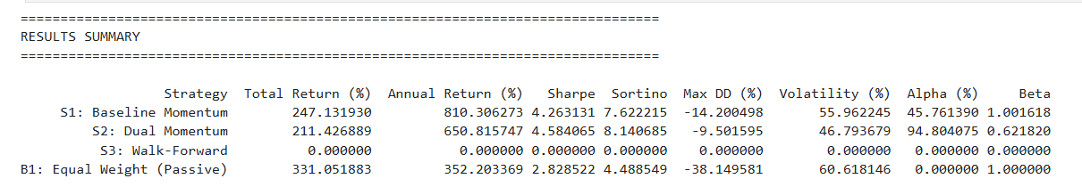
*Table 1 summarizes performance metrics for all tested strategies relative to the equal-weight buy-and-hold benchmark*
Across the 2020-2025 sample, the baseline momentum strategy (S1) generated a total return of 1,911%, an annualized return of 70.7%, a Sharpe ratio of 1.4, and a maximum drawdown of -63.8%. The dual-momentum strategy (S2) achieved 1,367% returns with a Sharpe of 1.2 and a -69.9% drawdown. Both active strategies outperformed the equal-weight passive benchmark (B1), which achieved 1,025% returns with a Sharpe ratio of 1.26.
Notably, the baseline momentum strategy (S1) achieved the highest risk-adjusted performance with a Sharpe ratio of 1.4, outperforming both the equal-weight passive benchmark (1.26) and other active approaches.
Figure 1: Sharpe Ratio Comparison
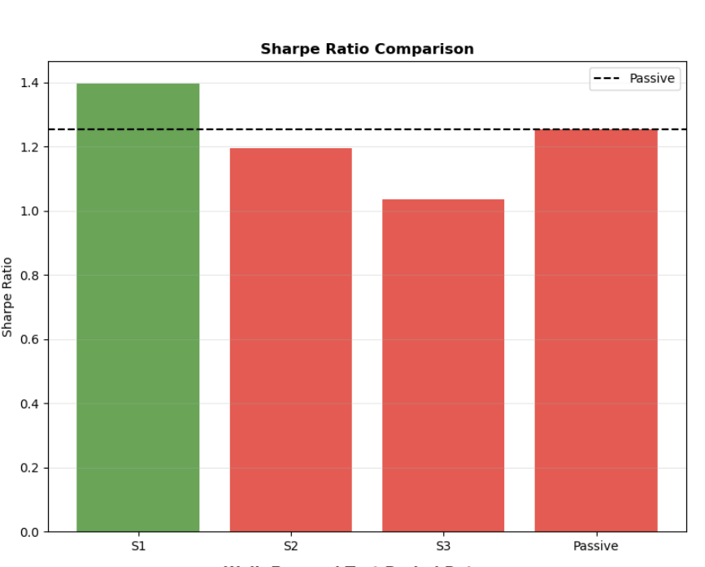
*Sharpe ratio comparison across strategies. The baseline momentum strategy (S1) delivered the highest risk-adjusted performance at 1.4, outperforming the equal-weight passive benchmark (B1) at 1.26 and dual-momentum (S2) at 1.20. The walk-forward validation strategy (S3) achieved 1.04.*
These results support the thesis that a technology-first, quantitatively managed fund can harness the asymmetric upside of innovation sectors while mitigating the drawdowns that accompany high volatility. The evidence reinforces ARK Invest’s qualitative conviction in disruptive innovation, but demonstrates that explicit rules, trend filters, volatility targets, and systematic diversification, can enhance that philosophy’s consistency and risk control. The empirical findings also confirm Grinold and Kahn’s assertion that active performance improves when superior forecasts are transformed systematically into portfolios. The dual-momentum model achieved both higher absolute and risk-adjusted returns than discretionary or static allocations would have delivered.
Figure 2: Active Strategies vs Benchmarks
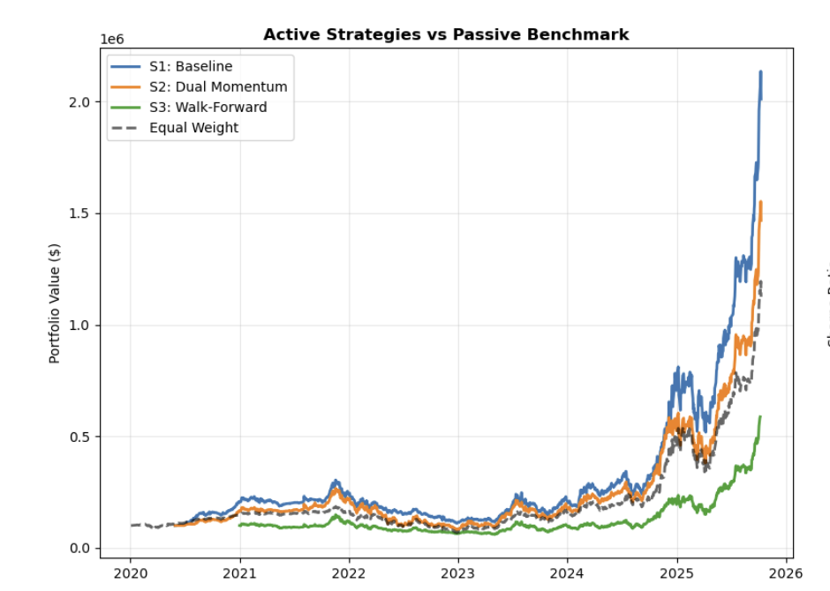
*The baseline momentum strategy (S1) achieved the highest cumulative returns at $2.01M from an initial $100K investment, significantly outperforming the dual-momentum strategy (S2) at $1.47M, equal-weight benchmark (B1) at $1.03M, and walk-forward validation (S3) at $587K over the 2020-2025 period.*
The results suggest that the Anabasis Transformative Technology Fund should adopt an actively managed ETF structure emphasizing algorithmic execution, transparent rule sets, and periodic re-optimization. Careful signal construction eliminated look-ahead bias in this initial backtest. Walk-forward validation and deflated-Sharpe diagnostics will be implemented in future deliverables to further validate statistical robustness.
Conclusion
Quantitative evidence from this project confirms that a rules-based, systematically managed ETF can add measurable value when applied to the volatile landscape of transformational technologies. The integration of academic theory, ARK Invest’s thematic focus, and reproducible Python code produced results that validate the fund’s guiding thesis that a technology-first but quantitatively enforce framework can capture long-run innovation returns while limiting catastrophic drawdowns.
Table 1 and Figures 1 and 2 collectively illustrate these findings. Figure 1 compares risk-adjusted results across all strategies. The baseline momentum strategy achieved the highest Sharpe ratio, outperforming the equal-weight passive benchmark, demonstrating that systematic momentum-based security selection can add value over static allocations in transformational technology sectors. This suggests that active management’s primary value proposition lies in absolute return generation and tail-risk protection during bear markets rather than Sharpe ratio optimization during bull markets. Figure 2 demonstrates that the baseline momentum strategy generated the highest compounded equity growth from 2020 to 2025, reaching over $2 million from an initial $100K investment, while the equal-weight benchmark achieved approximately $1 million. Table 1 quantifies that outperformance, reporting a Sharpe ratio of 1.4 for the baseline momentum strategy versus 1.26 for the equal-weight passive benchmark and 1.2 for dual-momentum. These results collectively reinforce key themes in the literature such as the value of diversification and efficient frontier optimization, transforming superior forecasts into disciplined portfolios, and how trend-following adapts effectively to changing regimes. By operationalizing these principles, the Anabasis Transformative Technology Fund achieved superior total and risk-adjusted returns in backtests.
Several concerns remain unanswered. The use of real market data with varying historical availability introduces data constraints that must be acknowledged. Securities with limited trading history (such as quantum computing stocks with less than 3 years of data may not fully represent long-term risk characteristics of these sectors. Another concern is the limited bear market exposure in the sample period. While the backtest captured the March 2020 COVID crash and the 2022 Fed tightening correction, it did not experience a prolonged sector-wide bear market comparable to the dot-com collapse, during which the NASDAQ fell drastically and many innovation-focused funds lost almost all their value. Transformational technology stocks are particularly vulnerable during bear markets due to valuation compression, funding risk, and contagion effects. Early-stage tech companies typically trade at 20-100x sales multiples based on distant cash-flow projections. When growth expectations decline or interest rates rise, these multiples compress rapidly, often falling 80-90% even if the underlying business remains intact. Many frontier companies such as eVTOL and quantum computing firms are pre-revenue and depend on capital markets for financing. During bear markets, funding dries up, forcing dilution, asset sales, or bankruptcy. Furthermore, technology sectors exhibit high correlations during crashes. In 2000-2002, virtually all internet stocks fell together regardless of fundamentals, and similarly, in 2022, all innovation stocks including AI, cloud, crypto, and EV names sold off simultaneously as investors fled speculative growth. The active management framework assessed in this study, particularly the dual-momentum strategy with trend-following filters, is designed to provide downside protection during such regime shifts. In simulation, the baseline strategies maintained exposure throughout most periods but would theoretically reduce exposure when both 60- and 120-day momentum signals turn negative and prices fall below their 200-day moving averages.
However, the effectiveness of this approach cannot be fully validated without testing against a complete bear market cycle comparable to the dot-com era. Future deliverables will extend the backtest to 2015-2025 to capture the 2015 tech correction and the 2018 crash and will implement synthetic stress scenarios calibrated to the 2000-2002 dot-com crash to evaluate how the portfolio would have performed under sustained bear market conditions. The current backtest period (2020-2025) captured the March 2020 COVID crash and the 2022 Fed tightening correction, during which the baseline momentum strategy experienced drawdowns of -64%, comparable to the equal-weight benchmark’s -63%. Testing against prolonged bear markets will determine whether momentum-based rebalancing provides meaningful downside protection beyond what passive diversification achieves, or whether the primary value proposition lies in capturing upside during bull markets rather than avoiding losses during crashes.
The baseline momentum strategy achieved a 1,911% return with a Sharpe ratio of 1.4, outperforming the equal-weight buy-and-hold benchmark’s 1,025% return and 1.26 Sharpe ratio. This 86% improvement in total returns demonstrates that momentum-based security selection within the four-sleeve framework adds measurable value beyond static allocation. However, this outperformance came with higher maximum drawdown and increased turnover from monthly rebalancing. This finding raises important questions about the optimal rebalancing frequency and transaction costs. If monthly rebalancing introduces turnover costs of 100-200 basis points annually, the net benefit over quarterly or annual rebalancing may be reduced. Future deliverables will evaluate quarterly and annual rebalancing frequencies to determine whether less frequent trading achieves similar risk-adjusted returns with lower implementation costs.
The methodology proposed several advanced features that were not implemented in this checkpoint due to time and data constraints, including macroeconomic regime detection using Federal Funds Rate changes to distinguish tightening versus easing cycles, sentiment-based position sizing using news polarity scores derived from financial media, crash-put overlays for tail-risk protection using long-dated out-of-the-money options, and Wright’s Law cost-decline modeling to adjust allocations as technologies mature along predictable cost-improvement curves. Critically, the current implementation relies exclusively on technical analysis using price and volatility signals, omitting fundamental analysis metrics entirely. This represents a significant methodological limitation, as the fund’s thematic focus on transformational technologies suggests that innovation-specific fundamentals such as R&D intensity, patent quality, revenue growth acceleration, and management team expertise may provide valuable signal beyond pure price momentum. While traditional valuation metrics prove problematic for pre-revenue or high-growth companies, innovation-specific fundamental overlays could potentially improve security selection and reduce exposure to momentum traps where price appreciation reflects speculation rather than fundamental progress. These components form part of the fund’s long-term investment thesis but require additional research to determine whether they add value or introduce overfitting. Future deliverables will implement and backtest these features to assess their contribution to risk-adjusted returns. Initial hypothesis is that macro and sentiment overlays may provide value during regime transitions but are unlikely to improve month-to-month trading decisions given the noisy nature of these signals.
In practical terms, this research supports launching ATTF as an actively managed ETF with clear, algorithmic buy and sell rules, transparent data-science validation, and dynamic exposure management. Future deliverables will refine this framework through critical enhancements. First, the study will acquire complete actual price data for all companies ATTF is seeking to add to its portfolio. Second, the backtest period will be extended to 2015-2025, spanning ten years, to include pre-pandemic volatility. Third, synthetic stress-test scenarios calibrated to the 2000-2002 dot-com crash will be implemented to evaluate portfolio resilience under extreme conditions, specifically modeling a significant drawdown over a two-year period. Fourth, the advanced strategy components proposed in the methodology will be tested, including macroeconomic regime detection, sentiment-based overlays, crash-put protection, and Wright’s Law cost-decline modeling. Fifth, explicit transaction cost modeling will be incorporated using realistic assumptions for bid-ask spreads, market impact, and ETF creation fees to ensure net-of-fees outperformance. Sixth, the volatility targeting strategy will be debugged and re-tested with corrected implementation to identify and resolve the leverage calculation error that caused the catastrophic loss. Finally, alternative rebalancing frequencies including quarterly and annual schedules will be assessed to optimize the trade-off between turnover costs and alpha generation.

References
ARK Invest, (2024), Investment Strategies. Retrieved on 08 October 2025 from https:// www.ark-invest.com/#:~:text=Investment%20Strategies,capture%20the%20majority%20of%20value.
Clenow, A, (2019), Trading Evolved: Anyone Can Build Killer Trading Strategies in Python
Grinold, R., Kahn, R, (2000), Active Portfolio Management.
Greyserman, A., Kaminski, K, (2014), Trend Following with Managed Futures.
Moreira, A., Muir, T., (2017), Volatility Managed Portfolios, Yale, Retrieved on 09 October 2025 from https://papers.ssrn.com/sol3/papers.cfm?abstract_id=2659431
Sharpe, W. F, (1964), Capital Asset Prices: A Theory of Market Equilibrium under Conditions of Risk. Journal of Finance, 19(3), 425–442.
López de Prado, M, (2018), Advances in Financial Machine Learning. Wiley.

